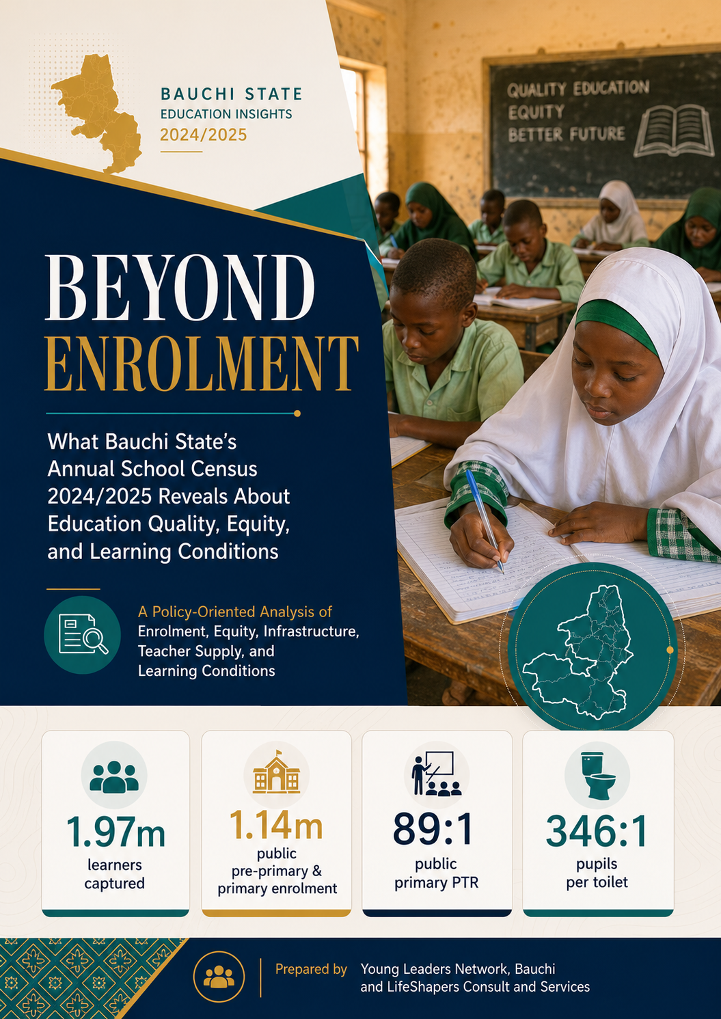
\
Abbreviation | Meaning
ASC | Annual School Census
BESDA | Better Education Service Delivery for All
CBMC | Centre-Based Management Committee
CR | Completion Rate
DHIS2 | District Health Information System 2
DNEMIS | Digitized National Education Management Information System
DRG | Dropout Rate by Grade
EMIS | Education Management Information System
ESP | Education Sector Plan
FME | Federal Ministry of Education
GEP | Girls’ Education Project
GER | Gross Enrolment Rate
GIR | Gross Intake Ratio
GIRLG | Gross Intake Ratio in the Last Grade of Primary
GPI | Gender Parity Index
ICT | Information and Communication Technology
IQS | Integrated Qur’anic Schools
IQTE | Integrated Qur’anic and Tsangaya Education
JSS | Junior Secondary School
LGA | Local Government Area
LGEA | Local Government Education Authority
MOE / MoE | Ministry of Education
MTSS | Medium Term Sector Strategy
NCE | Nigeria Certificate in Education
NER | Net Enrolment Rate
NIR | Net Intake Ratio
PCR | Pupil-Classroom Ratio
PF | Parents Forum
PFT | Percentage of Female Teachers
PGGE | Percentage Gender Gap in Enrolment
PPE | Percentage of Private Enrolment
PQT | Percentage of Qualified Teachers
PRS | Planning, Research and Statistics
PTA | Parent-Teacher Association
PTR | Pupil-Teacher Ratio
RRG | Repetition Rate by Grade
SBMC | School-Based Management Committee
SDP | School Development Plan
SSS | Senior Secondary School
ST&V | Science, Technical and Vocational
SUBEB | State Universal Basic Education Board
TVET | Technical and Vocational Education and Training
UIS | UNESCO Institute for Statistics
UNESCO | United Nations Educational, Scientific and Cultural Organization
UNICEF | United Nations Children’s Fund
WASH | Water, Sanitation and Hygiene

Executive Summary
The 2024/2025 Annual School Census gives Bauchi State enough figures to make clearer choices. It also shows a school system carrying more children than its teachers, classrooms, toilets and water points can comfortably support. The census covers 6,328 schools and centers across public, private and IQTE/IQS provision. Together, these institutions account for about 1.97 million learners. Public pre-primary and primary schools alone carry 1.14 million pupils, almost six times public Junior Secondary School (JSS) enrolment and more than eleven times public Senior Secondary School (SSS) enrolment.
The first message is straightforward: Bauchi has brought many children into school, and girls are now close to parity at most formal levels. But school conditions have not kept pace with enrolment. Public pre-primary and primary schools report a state-wide pupil-teacher ratio of 95:1, a pupil-classroom ratio of 122:1 and a pupil-toilet ratio of 346:1. These figures are not administrative details. They shape lesson quality, teacher attention, classroom discipline, girls' dignity, health, and children's willingness to remain in school.
The gender picture also needs more careful reading. Girls are 51% of public primary enrolment, 49% of public JSS, and 48% of public SSS. Private schools show a slightly higher female share at secondary level. This does not mean Bauchi has solved girls' education. It means the next discussion should move from enrolment numbers alone to retention, learning, safety, WASH, transition to senior secondary and girls' participation in science, technical and vocational schools.
The recommendations in this report follow those figures. Where the data points to overcrowding, the response is classroom rehabilitation, furniture and targeted construction. Where the data points to high pupil-teacher ratios, the response is better teacher deployment and recruitment. Where the data points to poor toilets and water, the response is a WASH and dignity programme. Where the data shows a sharp drop in enrolment after primary, the response is a transition and retention plan. Where the tables show inconsistencies, the response is better EMIS validation before figures are used for budgeting.

Ten Findings That Should Guide Decisions
- Bauchi's public basic education system is large: public pre-primary and primary schools enroll 1,144,255 pupils across 3,454 responding schools.
- Public primary enrolment is heavily concentrated in Bauchi, Katagum, Toro, Ningi and Zaki, but the highest service pressure is found in places such as Zaki, Toro, Warji, Katagum and Itas-Gadau.
- Public JSS enrolment is 213,597, while public SSS enrolment is 98,321. This sharp thinning after primary requires a focused transition and retention agenda.
- IQTE/IQS serves 114,697 learners in 549 centers, but coverage is uneven. Some LGAs report no IQTE/IQS centres, while Zaki, Alkaleri and Ningi carry large shares.
- ST&V is too small for the state's skills and jobs agenda: only seven public Science, Technical and Vocational (ST&V) schools and 8,421 learners are reported.
- Girls are close to parity in most formal levels, but the ST&V pipeline remains male-skewed, with girls at about 40% of public ST&V enrolment.
- The teaching workforce is relatively qualified on paper: 82% of public pre-primary/primary teachers, 83% of JSS teachers, and 75% of SSS teachers are reported as qualified.
- Female teachers remain under-represented: 37% at public pre-primary/primary, 26% at JSS and 30% at SSS.
- The classroom problem is both quantity and quality: the census reports 20,738 usable classrooms and 3,972 unusable public classrooms.
- Water and sanitation remain a serious education issue. At public pre-primary/primary level, 61% of schools are reported with no source of safe water, and the pupil-toilet ratio is 346:1.

Bauchi Education System At A Glance
Bauchi's education system is not one simple block. It is made up of public formal schools, private formal schools, science and technical schools, and IQTE/IQS centres. Each part carries a different burden. Public primary schools carry mass enrolment. Private schools matter more in urban and semi-urban LGAs. IQTE/IQS carries a large non-formal learning population. ST&V should support skills and jobs, but the current footprint is too small for the number of young people who will need practical routes into work.
Sub-sector | Institutions | Learners | Female learners | Teachers/facilitators | Female teachers
Public pre-primary/primary | 3,454 schools | 1,144,255 | 50.4% | 12,048 | 37.2%
Public JSS | 843 schools | 213,597 | 49.0% | 6,961 | 25.6%
Public SSS | 212 schools | 98,321 | 47.5% | 2,907 | 30.1%
Public ST&V | 7 schools | 8,421 | 40.5% | 184 | 14.1%
IQTE/IQS | 549 centres | 114,697 | 42.8% | 2,378 | 22.8%
Private formal | 1,264 schools | 389,625 | 50.6% | Not consolidated | -
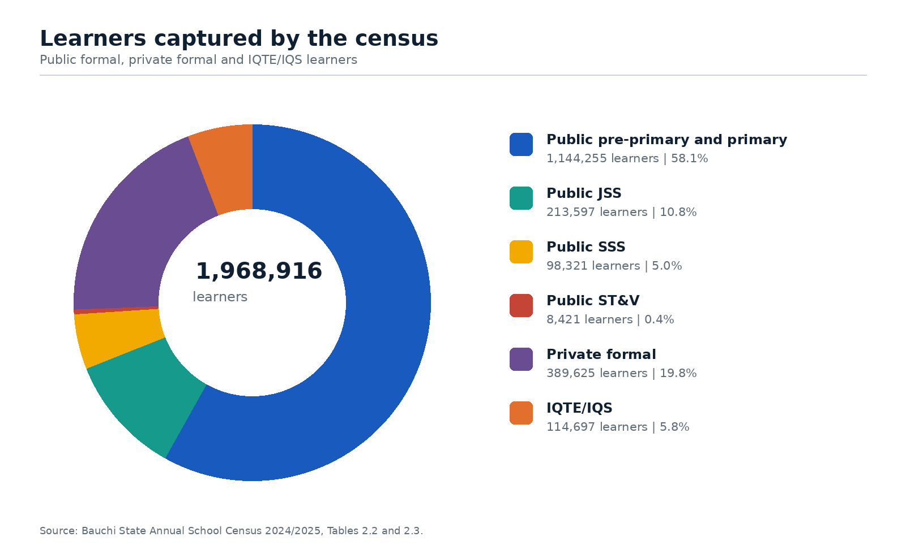
Figure 2: Learners captured in the census by provision type.

Education Access, Participation and Transition
Pre-Primary Education: A Growing Foundation for Early Learning: The census reports 139,295 children in pre-primary education across public and private schools. Public provision accounts for 76,553 children (about the seating capacity of the Los Angeles Memorial Coliseum) while private provision accounts for 62,742. This is important because early learning in Bauchi is now too large to be treated as a small add-on to primary education. The private sector carries 45% of pre-primary enrolment, and in some LGAs private provision is the main entry point into organized early learning.
What this means for policy: Bauchi needs a pre-primary quality framework that covers both public and private schools. The framework should spell out minimum expectations for caregivers, learning materials, child protection, school readiness, and private school compliance. Without this, children will enter Primary 1 with very different levels of preparation depending on where their parents live and what they can pay.
Primary-Level Pressure Drives Classroom and Teacher Gaps: Primary education remains the largest part of the system. Public primary enrolment is 1,067,702, while private primary enrolment is 240,271. Public schools carry about 82% of primary enrolment. Any serious improvement in learning, foundational literacy and numeracy, girls' retention or out-of-school reduction has to begin with public primary schools.
The largest public pre-primary/primary enrolment is recorded in Bauchi LGA with 141,348 pupils, followed by Katagum with 120,200, Toro with 97,035, Ningi with 80,476 and Zaki with 69,447. These LGAs deserve attention because of scale. But the state should not allocate resources by enrolment alone. Zaki, Toro, Warji, Katagum and Itas-Gadau show severe pressure on teachers, classrooms, or toilets. A fair resource formula should combine enrolment, deprivation, infrastructure condition and gender-sensitive WASH needs.
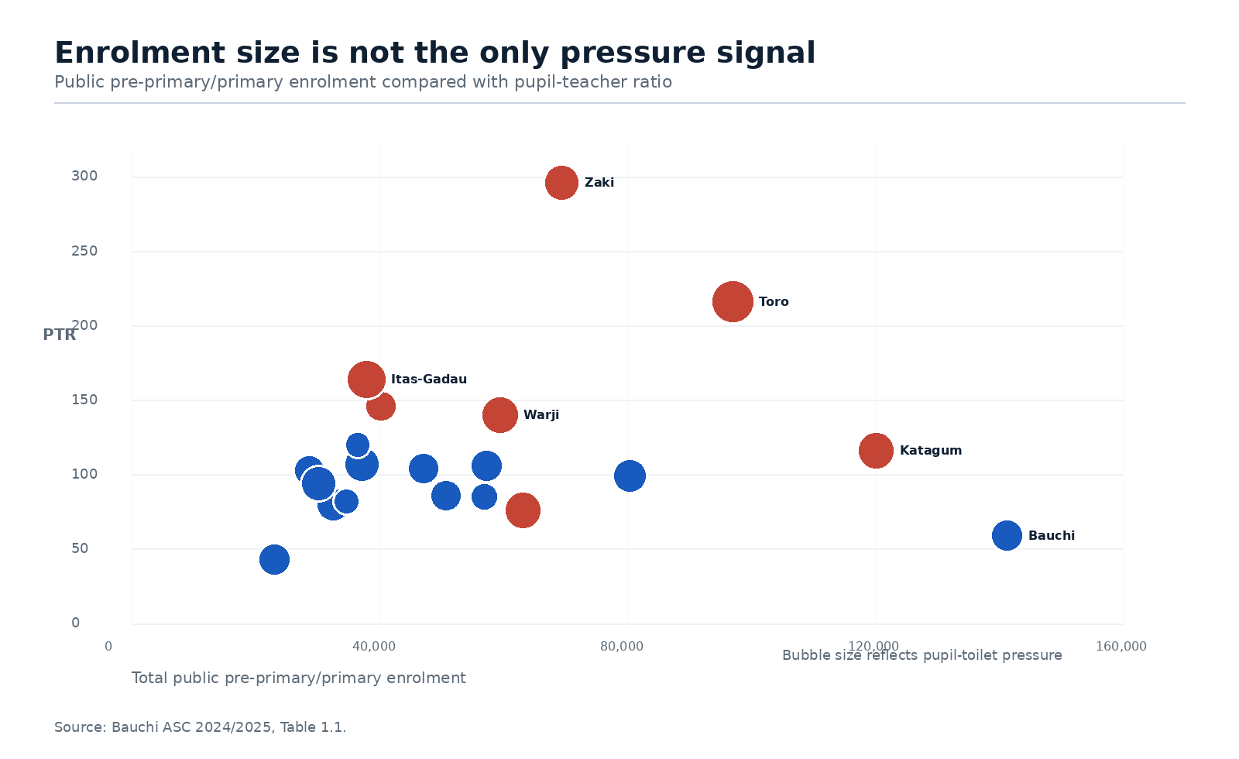
Figure 3: Enrolment pressure and pupil-teacher pressure in public pre-primary/primary schools.
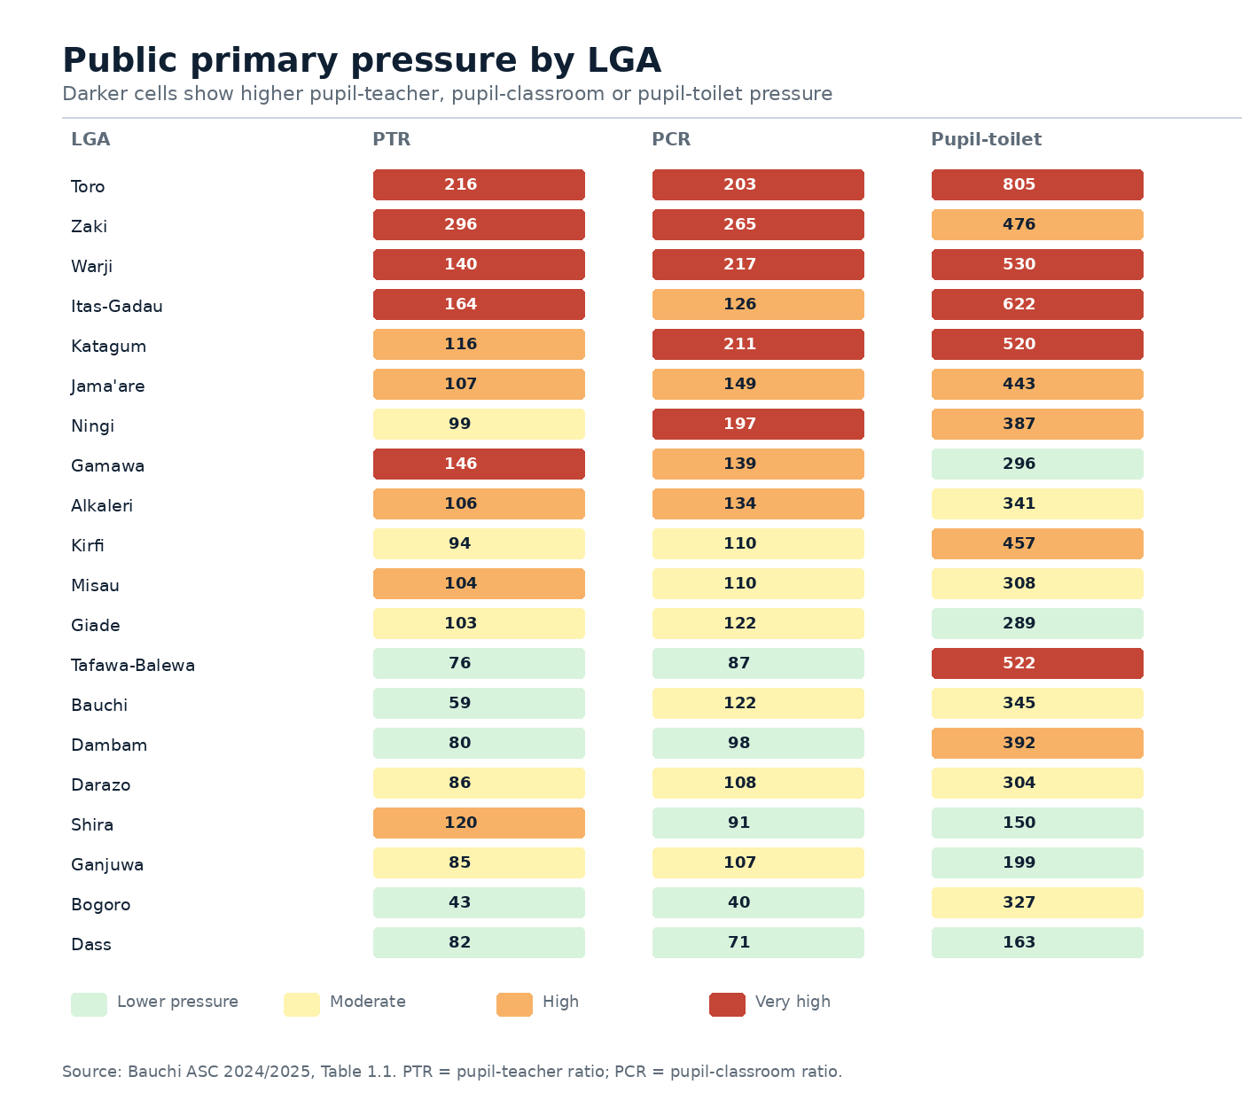
Figure 4: Primary pressure ranking across teachers, classrooms, and toilets.
Private Schools: Expanding Access, but Unevenly Distributed: Private schools are part of Bauchi's education delivery, but they are not evenly distributed. At primary level, private enrolment is strongest in Bauchi, Toro, Katagum, Tafawa-Balewa and Giade. Bauchi LGA alone records 61,171 private primary pupils, far ahead of many LGAs. The pattern suggests that private schools are filling demand where population concentration, household income and urban access make private provision viable.
What this means for policy: the state should not see private schools only as businesses to be checked after problems arise. The Ministry should use the ASC to track compliance, teacher qualification, pupil safety, fees where relevant, WASH and disability inclusion. Private schools should also submit timely and accurate EMIS returns as a condition for renewal of approval.
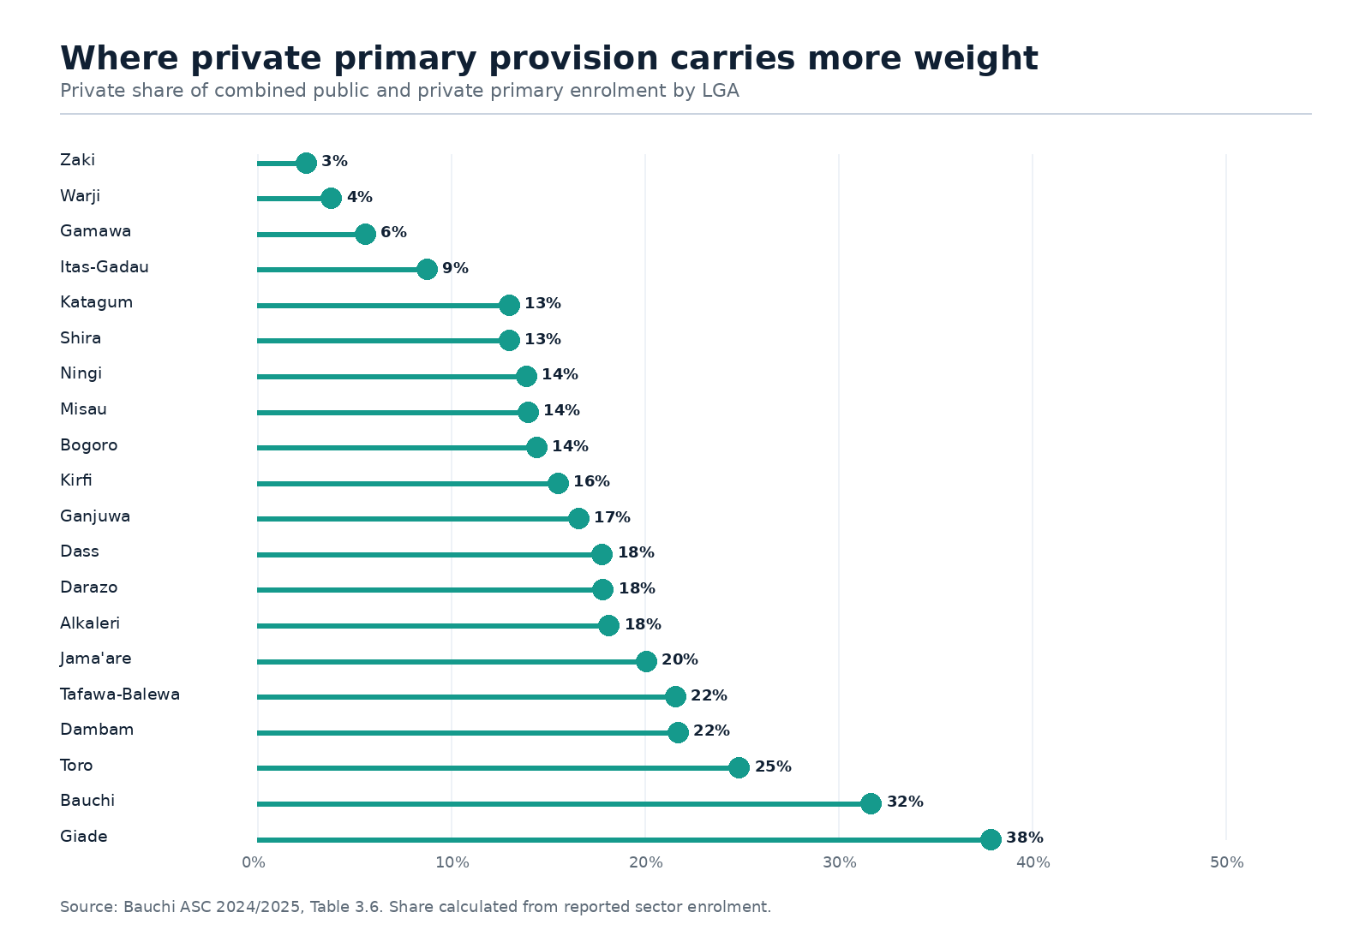
Figure 5: Private share of combined primary enrolment by LGA.

Transition Concern; JSS and SSS Enrolment Fall Far Below Primary Levels:
The census shows a large difference between primary and secondary enrolment. Public primary enrolment is more than one million, while public JSS enrolment is 213,597 and public SSS enrolment is 98,321. This chart should not be read as a cohort survival rate because the pupils are not the same cohort. Even so, the scale difference is too large to ignore. It points to transition pressure, repetition, late entry, household cost barriers, distance to secondary schools, early marriage, child labor, insecurity in some communities, and the limited attractiveness of post-basic pathways.
What this means for policy: Bauchi needs a transition plan from Primary 5 through JSS 2. It should include school-by-school transition tracking, targeted bursary or material support for poor households, SBMC follow-up for girls at risk of dropping out, safe transport or community escort arrangements where distance is a barrier, and a clear re-entry route for married adolescents and adolescent mothers under the state's policy commitments.

Non-Formal and Qur’anic Education Pathways:
IQTE/IQS centres enrol 114,697 learners, more than the public SSS sector. This is not a side issue. Zaki alone records 24,539 IQTE/IQS learners, followed by Alkaleri with 17,862 and Ningi with 17,013. At the same time, several LGAs report no IQTE/IQS centres. The distribution suggests that IQTE/IQS is deeply localised and should be handled through a careful integration strategy rather than a one-size-fits-all programme.
What this means for policy: Bauchi should connect IQTE/IQS more clearly to foundational literacy, numeracy, life skills and transition opportunities. This requires accurate centre mapping, facilitator training, learning materials, child protection safeguards and a data check that corrects the apparent ratio problems in the current table.

Science, Technical and Vocational Education: Too Limited for Bauchi’s Skills Development Needs:
The census reports only seven public science, technical and vocational schools with 8,421 learners. For a state with a young population, agricultural economy, growing urban centres and a need for employable skills, this is too small. ST&V also shows a gender concern: girls are about 40% of enrolment. In some LGAs, female participation in technical pathways is far lower.
What this means for policy: ST&V should sit inside both the education plan and the state's jobs agenda. Bauchi should expand technical options in phases, beginning with trades and science options that fit the state's economy: agricultural technology, renewable energy maintenance, construction skills, ICT, health support services, creative and digital production, and small enterprise support. Girls' participation should be planned from the beginning, not added later.
Female Participation Still Needs Targeted Support:
The census challenges a simplistic reading of gender exclusion. At the aggregate level, girls are present in large numbers: 51% of public primary enrolment, 49% of public JSS and 48% of public SSS. Private schools record 50% girls at primary, 52% at JSS and 52% at SSS. This means that enrolment parity is within reach in many places.
But parity is not the same as justice. Girls may be enrolled and still face poor toilets, lack of menstrual hygiene support, distance to school, early marriage pressure, household labour, weak protection systems and limited access to science and technical tracks. A policy that celebrates parity without fixing these conditions will lose girls later, especially during adolescence.
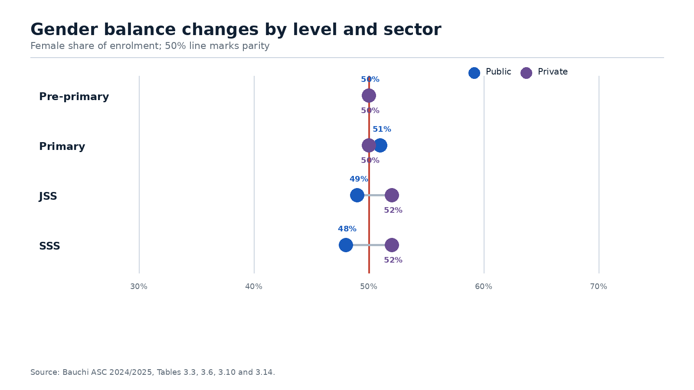
Figure 6: Female share of enrolment by level and sector.
Level | Public female share | Private female share | Policy reading
Pre-primary | 50% | 50% | Parity largely achieved
Primary | 51% | 50% | Strong parity, with LGA variations
JSS | 49% | 52% | Near parity; transition still needs attention
SSS | 48% | 52% | Girls' presence stronger in private SSS than public SSS
ST&V | 40% public overall | - | Male-skewed route needing planned support for girls

Pupil-Teacher Ratios Reveal Uneven Workforce Distribution:
The census reports 22,100 teachers (about the seating capacity of Madison Square Garden) across public formal schools. On qualification, Bauchi has a base to build on: 82% of public pre-primary/primary teachers, 83% of JSS teachers and 75% of SSS teachers are reported as qualified. The harder problem is the number of teachers, where they are posted, the subjects they can teach and the gender mix of the workforce.
At public pre-primary/primary level, the state-wide pupil-teacher ratio is 95:1 of the clearest staffing pressure in the census. Some LGAs are far above the state average: Zaki is reported at 296:1, Toro at 216:1, Itas-Gadau at 164:1, Gamawa at 146:1 and Warji at 140:1. These ratios make individual attention difficult and weaken foundational learning.
The gender composition of teachers also matters. Female teachers are 37% at public pre-primary/primary, 26% at JSS and 30% at SSS. In many communities, female teachers support girls' retention, parent confidence, adolescent counselling and reporting of protection concerns. The low female share at JSS is particularly important because this is the level where many girls face stronger social pressure to leave school.
Level | Teachers | Qualified | Female teachers | Immediate policy concern
Pre-primary/primary | 12,048 | 82% | 37% | Deploy teachers to high-PTR LGAs; improve early-grade teaching
JSS | 6,961 | 83% | 26% | Address subject gaps and recruit/deploy more female teachers
SSS | 2,907 | 75% | 30% | Improve subject-specialist coverage and STEM teaching capacity
ST&V | 184 | Not fully disaggregated in this analysis | 14% | Expand technical instructors and female technical role models

Classroom, Toilet and Furniture Gaps Are Severe:
The infrastructure picture is severe. The census reports about 20,738 usable classrooms across public and private schools, with 3,972 unusable public classrooms. In public pre-primary/primary schools, 9,378 usable classrooms serves 1.14 million pupils, giving a pupil-classroom ratio of 122:1. That ratio is not just a facilities statistic; it is a learning statistic. Crowded classrooms reduce teacher movement, group work, feedback, and classroom control.
The classroom condition data shows that the challenge is not only building new rooms. Existing classrooms need repair, seating and basic learning fixtures. Using the reported counts, about 4,156 usable public primary classrooms need major repairs, 7,983 have insufficient seating and 5,340 lack a good blackboard. This means a classroom rehabilitation package may produce faster gains than new construction alone in some LGAs.
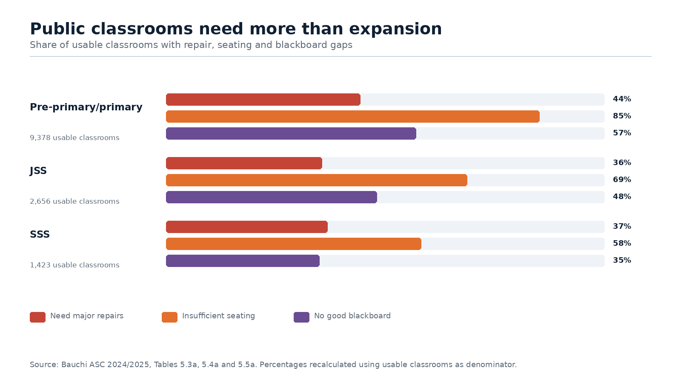
Figure 7: Condition of usable public classrooms.
WASH is one of the strothest warnings in the census. Public pre-primary/primary schools have a pupil-toilet ratio of 346:1. Toro is reported at 805:1, Itas-Gadau at 622:1, Warji at 530:1, Tafawa-Balewa at 522:1 and Katagum at 520:1. These figures affect all children, but girls carry a particular burden when sanitation is poor, especially from upper primary into adolescence.
Water access is also weak at basic level. The report shows that 61% of public pre-primary/primary schools have no safe water source. The situation improves at SSS level, where 22% report no source, but the basic education gap is still too high. WASH spending should be treated as a retention, dignity and health measure, not only as an infrastructure line item.
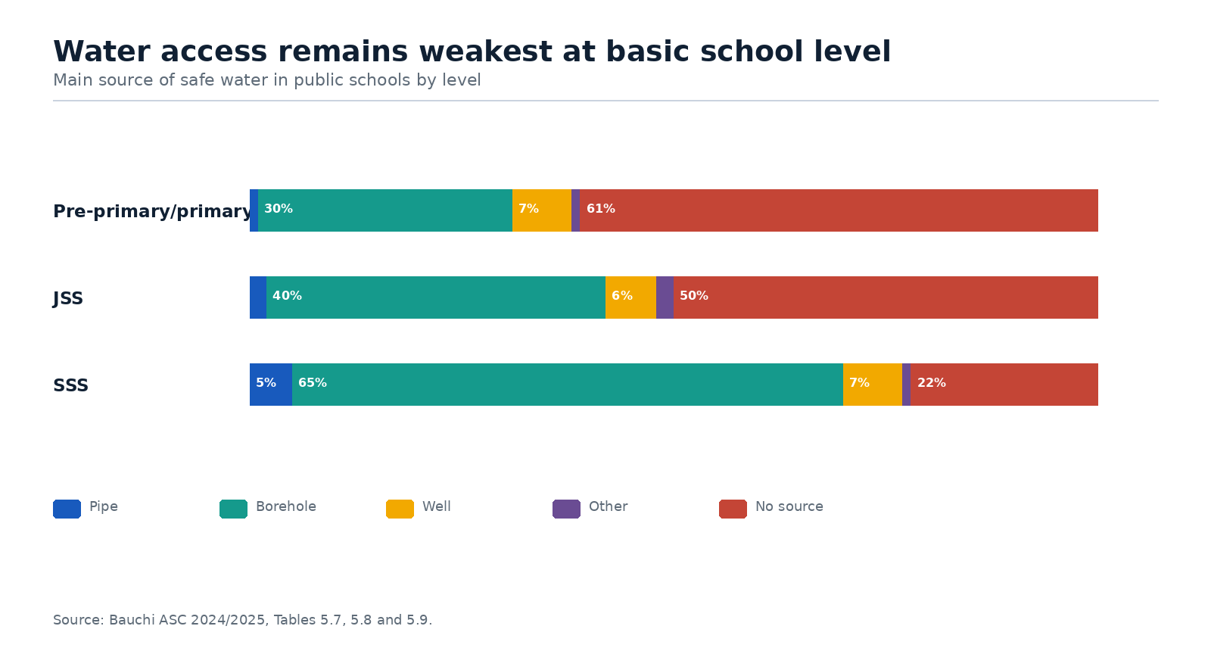
Figure 8: Main source of safe water in public schools.

Special Needs Education and Inclusive School Planning:
The census includes learners with visual impairment, physical disabilities, hearing or speech impairment and mental/challenging learning needs. This is important because disability is often invisible in routine school planning. The presence of these learners in the census should push Bauchi to move from counting children with disabilities to planning for them.
The next step is a practical inclusion package: screening and referral, teacher orientation on inclusive classroom practice, accessible toilets, ramps and seating, assistive learning materials, links with health and social welfare services, and targeted school grants for children with specific learning needs. Inclusion should also be added to SBMC monitoring so that children with disabilities are not only enrolled but actually learning.

Enrolment, Teacher and Facility Gaps Differ Sharply by LGA:
A state-wide average hides local pressure. Bauchi needs an LGA prioritisation method that distinguishes between size and stress. A large LGA may need more absolute investment because it serves many children. A smaller LGA may need urgent support because its ratios are extreme. The table below groups LGAs by the type of pressure visible in the public pre-primary/primary data.
Pressure lens | Top five LGAs
Largest enrolment | Bauchi (141,348); Katagum (120,200); Toro (97,035); Ningi (80,476); Zaki (69,447)
Highest pupil-teacher pressure | Zaki (296); Toro (216); Itas-Gadau (164); Gamawa (146); Warji (140)
Highest pupil-classroom pressure | Zaki (265); Warji (217); Katagum (211); Toro (203); Ningi (197)
Highest pupil-toilet pressure | Toro (805); Itas-Gadau (622); Warji (530); Tafawa-Balewa (522); Katagum (520)
For implementation, this report recommends a three-tier LGA approach. Tier 1 should include LGAs with both large enrolment and high service pressure. Tier 2 should include LGAs with extreme ratios even if enrolment is smaller. Tier 3 should include LGAs with moderate ratios but specific gaps such as water, female teacher shortage or weak transition to secondary school. This is fairer than spreading small projects thinly across all LGAs.

Policy Recommendations
- Launch a Basic Education Decongestion Plan: Public pre-primary/primary schools enrol 1,144,255 pupils, with a state-wide pupil-classroom ratio of 122:1 and 3,972 unusable public classrooms. Action: identify the worst schools and LGAs, then combine classroom rehabilitation, furniture supply, targeted new construction and school mapping. New classrooms should not be approved without furniture, toilets and a realistic teacher plan.
- Adopt a Teacher Deployment and Recruitment Compact: The public pre-primary/primary PTR is 95:1, with Zaki at 296:1, Toro at 216:1, Itas-Gadau at 164:1, Gamawa at 146:1 and Warji at 140:1. Action: tie recruitment and posting to school-level PTR, subject gaps and rural hardship needs. Set female teacher recruitment and posting targets, especially for JSS where only 26% of teachers are female.
- Treat WASH as a Girls' Education and Retention Investment: Public pre-primary/primary schools report a pupil-toilet ratio of 346:1, and 61% have no safe water source. Some LGAs are far worse, including Toro at 805 pupils per toilet and Itas-Gadau at 622. Action: prioritise toilets, water and menstrual hygiene facilities in upper primary, JSS and SSS, starting with the worst LGA and school ratios.
- Build a Primary-to-Secondary Transition Programme: Public primary enrolment is over one million, while public JSS enrolment is 213,597 and public SSS enrolment is 98,321. The figures are not a cohort survival rate, but they show a much thinner system after primary. Action: track Primary 5 to JSS 2 movement by school and gender, and use SBMCs, guidance teachers and community leaders to follow learners at risk.
- Expand ST&V With Girls Planned In From The Start: Public ST&V enrolment is only 8,421 across seven schools, and girls are about 40% of enrolment. Action: expand technical streams in phases, linked to Bauchi's economy, while providing girls' STEM clubs, safe transport or boarding where needed, female instructors and career guidance that challenges the idea that technical education is only for boys.
- Bring IQTE/IQS Into The Main Planning Table: IQTE/IQS enrols 114,697 learners across 549 centres, more than public SSS enrolment. Zaki, Alkaleri and Ningi carry large numbers, while some LGAs report no centres. Action: map centres, validate learner and facility data, train facilitators and develop bridge content for literacy, numeracy, life skills and child protection.
- Tighten EMIS Quality Control Before Publication: The report contains apparent anomalies in some class totals, ratio columns and narrative descriptions. Action: future ASC reports should include a short validation note listing corrections made, unresolved issues, missing data and tables that should not yet be used for costing or sanctions.
- Link Budget Releases To The ASC Priority Map: The census identifies the LGAs with the largest enrolment, highest PTR, highest PCR and worst toilet pressure. Action: quarterly education budget reviews should show which high-pressure LGAs received releases for teachers, classrooms, furniture, water and toilets, and what changed after the release.

Conclusion:
The Bauchi ASC 2024/2025 report should not sit on a shelf as an official statistical document. It should become a working tool for budget choices, teacher deployment, classroom rehabilitation, school WASH, girls' retention, private school regulation and local accountability. The numbers show a system with wide reach and real progress, especially on gender parity. They also show classrooms and teachers stretched too thin, toilets far below need, and technical education too small for the future Bauchi is trying to build.
The practical question is no longer whether Bauchi has education data. It does. The question is whether the state will use the data to choose priorities, fund them, track them and explain progress to citizens in language they can understand.

